

**Application Development**

NQF Level 7 (14 credits)

**Project assignment**

**(Worth 80% of the final grade)**

**90 Marks**

**Final Result: _______________ Assessor Signature ___________________**

|  |  |  |
| --- | --- | --- |
| **Student Name** | **Student ID** | **Student Signature** |
| Liana Pak | yib000013o |  |
| Omid Ardakani | yib00001kq |  |
| Sviatlana Belabarodava | yib00001yl |  |

**Table of Content**

1. Project Proposal 3

1.1 Introduction and description 3

1.2 Purpose and objectives of the system 3

1.3 Business Requirements of the system 3

1.4 Identified users 3

1.5 Timeline of the project 4

2. Analysis and design of your application software 4

2.1 Use case Diagram / User Function Description 4

2.2 ER Diagram 6

2.3 UI Design Navigation Flow 7

2.4 State Machine Diagram 8

3. Implementation of system application 8

3.1 Code logic 8

3.2 Improved readability 8

3.3 Data validation 8

3.4 Authentication 8

4. Test and deploy of application 8

4.1 Test plan and test-cases 8

4.2 Screenshots of bugs 13

5. Project Marking Criteria 16

Overall Marks: 16

6. References 17

# Project Proposal

## Introduction and description

Company W is a New Zealand construction organization that is based in Auckland. It constantly has several objects under construction called projects and each of these projects has one or several sites. Employees are daily assigned to the sites depending on their specialization and qualification. Site managers have to track and approve workers’ working hours on a daily basis. After that Project Managers can reject or approve the Timesheet.

The idea of the project is to provide a solution for construction company W for tracking timesheet of workers in hierarchy structure of the company.

This project consists of 3 main modules, including Login, Registration, and Timesheet. The login module for authentication and authorization of users is based on their role in contracture projects. These roles include Project manager, Site manager, Workers, and Admin. Registration module is accessible only by Admin to define and register Project, Site, or Employee and assign roles to them. Timesheet module is accessible by the Site manager to create and approve the Timesheets. The project manager also has accessibility to the Timesheet module to approve or reject timesheets.

The team of developers consists of 3 people and it is estimated that application will be completed in 9 weeks.

## Purpose and objectives of the system

System Goal

The main goal of the system is to design and implement information system to handle timesheets at distributed construction sites managed by several Site Managers and Project Manager.

Objectives are following:

* eliminate printing out of timesheets and their sending by post from the original timesheet processing
* provide Site Manager with user-friendly UI for managing workers timesheet
* realize two-level approval process for timesheets to make approval process faster and clear
* keep information about working hours on selected date at sites/projects in electronic format for future report generation and integration with accounting system

## Business Requirements of the system

The company W is facing a problem of processing all the information described above using paper work. Documentation process includes:

* Attendance form printing out and filling in
* Approval by Site Manager with sending papers by post to the office
* Final Approval by Project Manager

All these issues lead to postpones in salary payment.

## Identified users

There are 3 main users of the system: Admin, Project Manager and Site Manager.

The login module for authentication and authorization of users is accessible by all users.

Admin has access to the Registration module and can define and register Project, Site, or Employee and assign roles to them.

Site Manager has access to the Timesheet module to create and approve the Timesheets.

Project manager also has accessibility to the Timesheet module to approve or reject the Timesheets.

## Timeline of the project

# Analysis and design of the application software

## Use case Diagram / User Function Description

The diagram displays the interactions of users and system

A close up of a map

Description generated with high confidence

These specifications are formed to capture the users’ fundamental needs within the system. They are formed based on Use case diagram for capturing functional requirements of the system.

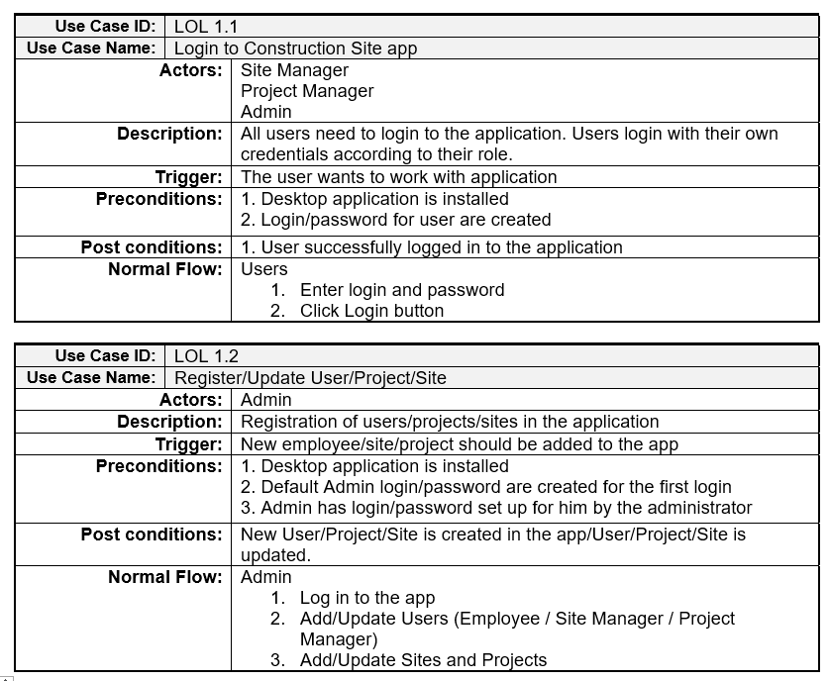

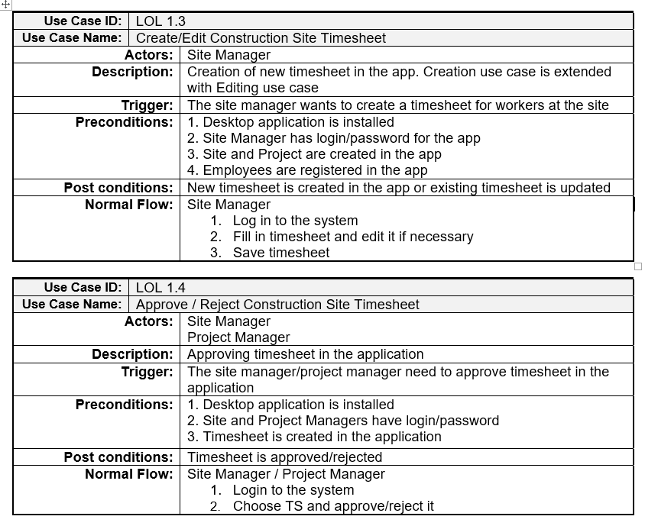

## ER Diagram

## 

## UI Design Navigation Flow

## 

## State Machine Diagram

The design documentation must be comprehensive and should be aligned with the approved proposed system.

You can choose any standard template for analysis and design reports or use the approved format.

# Implementation of system application

## Code logic

## Improved readability

## Data validation

## Authentication

# Test and deploy of application

## Test plan and test-cases

The desktop application is going to be tested on Windows OS in resolution of 1920*1018.

The testing will start by modules’ readiness, and application will be tested on integrational and system levels based on test-cases after the development is finished.

Functional requirements are in scope of testing the same as some non-functional as usability and security.

Test-cases are written in Excel and the defects will be tracked in Word document using GitHub.

The testing is considered finished when all test-cases are passed.

## 

## 

## 

## 

## Screenshots of bugs

LOL_issue_1

1. Log is as SM;
2. Choose the line with status “Approved by PM”;
3. Delete it.

Actual result: SM can delete the line with Status “Approved by PM”

Expected result: SM can’t delete the line with Status “Approved by PM”

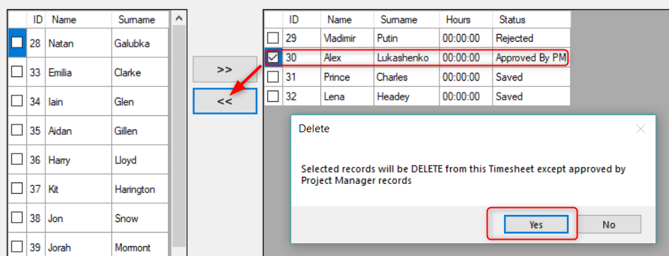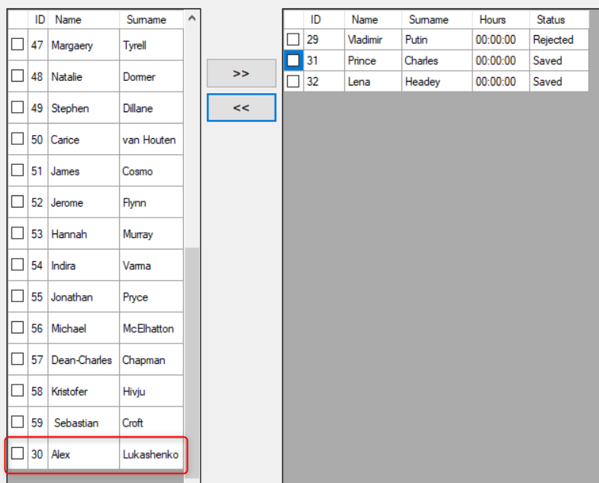

Resolution:

if (((bool)dataGridViewTS.Rows[i].Cells[0].FormattedValue) && dataGridViewTS.Rows[i].Cells[4].ToString() != "Approved by PM")

Was changed to:

if (((bool)dataGridViewTS.Rows[i].Cells[0].FormattedValue) && (dataGridViewTS.Rows[i].Cells[“Status”].Value.ToString() != "Approved By PM"))

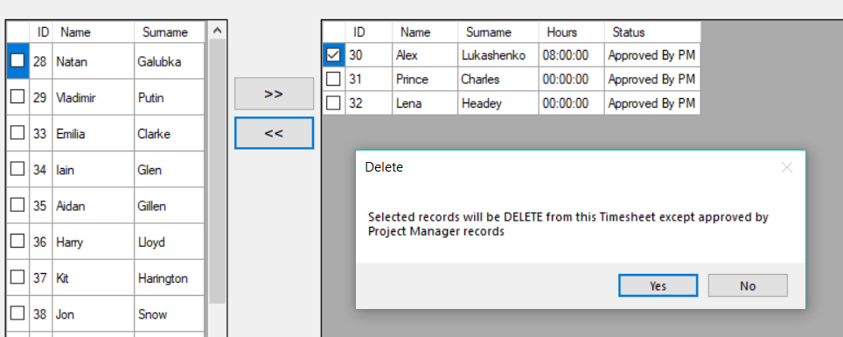

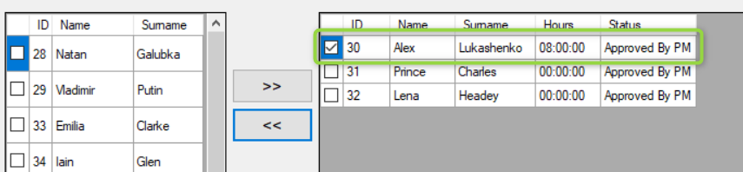

State machine diagrams

The diagrams are showing different variations of events that an object goes through.

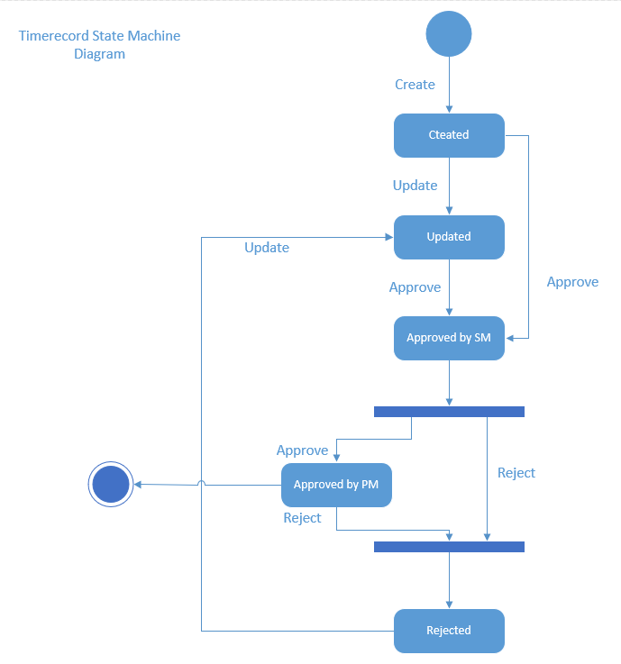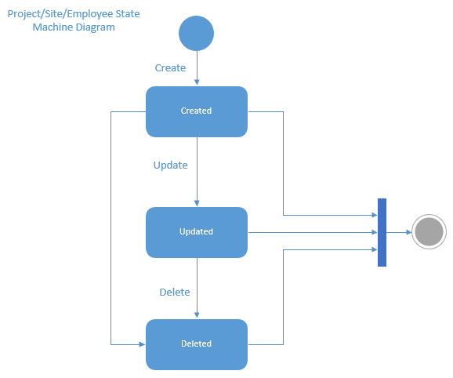

# Project Marking Criteria

|  |  |  |  |
| --- | --- | --- | --- |
| **Marking Criteria** | **Marks** | **Actual Marks** | **Comments / Feedback** |
| ***Task 1: Propose Your System*** |  |  |  |
| 1. Description of the proposed system is clear; System functionality to be developed is stated. | 5 |  |  |
| 1. Business Requirements are identified | 10 |  |  |
| 1. Users of the proposed system are identified | 5 |  |  |
| **Total Marks:** | **20** |  |  |
| ***Task 2: Design and analyse your application software*** |  |  |  |
| 1. UI Design Navigation Flow *(5 Marks)* | 5 |  |  |
| 1. Use case Diagram / User Function Description *(5 Marks)* | 5 |  |  |
| 1. ER Diagram *(5 Marks)* | 5 |  |  |
| 1. State Machine Diagram *(5 Marks)* | 5 |  |  |
| **Total Marks:** | **20** |  |  |
| ***Task 3: Develop your system application*** |  |  |  |
| 1. Code logic | 15 |  |  |
| 1. Improved readability (commented coding) | 5 |  |  |
| 1. Data validation | 10 |  |  |
| 1. Authentication | 10 |  |  |
| **Total Marks:** | **40** |  |  |
| ***Task 4: Test and deploy your application*** |  |  |  |
| 1. At least 10 comprehensive test cases were generated and recorded. | 5 |  |  |
| 1. Screenshots of bugs found were attached. | 5 |  |  |
| **Total Marks:** | **10** |  |  |
| Overall Marks: | **90** |  |  |

# References

IBM Knowledge center. (n.d.) *Use-case specification outline* Retrieved from: https://www.ibm.com/support/knowledgecenter/en/SSYMRC_4.0.5/com.ibm.rational.rrm.help.doc/topics/r_uc_spec_outline.htmlrational.rrm.help.doc/topics/r_uc_spec_outline.html

Visual Paradigm. (n.d.) *What is Activity Diagram?* Retrieved from: https://www.visual-paradigm.com/guide/uml-unified-modeling-language/what-is-activity-diagram/

Visual Paradigm. (n.d.) *What is Communication Diagram?* Retrieved from: https://www.visual-paradigm.com/guide/uml-unified-modeling-language/what-is-communication-diagram/

Visual Paradigm. (n.d.) *What is Sequence Diagram?* Retrieved from: <https://www.visual-paradigm.com/guide/uml-unified-modeling-language/what-is-sequence-diagram/>

Use-case

Er-diagram

State-machine

Ui design navigation flow